CARE OF ORPHANED

RACOONS

Compiled by

Laurel A. Beechey

[lbeechey@rogers.com](mailto:lbeechey@rogers.com)

94 North St. W.

Tillsonburg, On.

Canada N4G1C3

519-842-9416

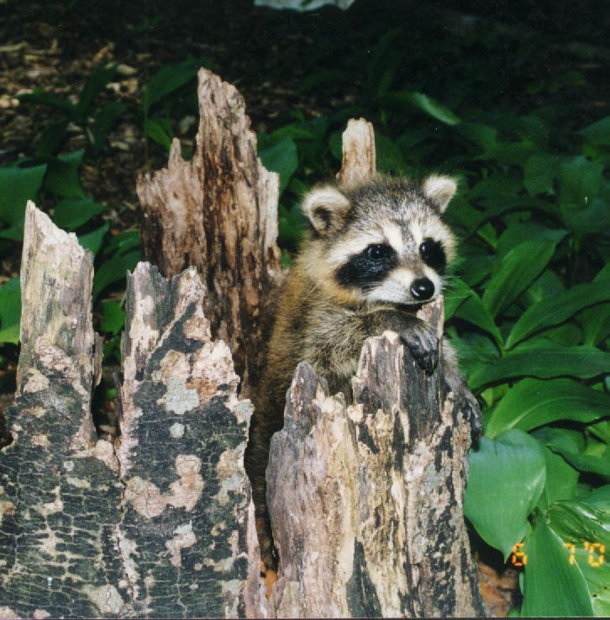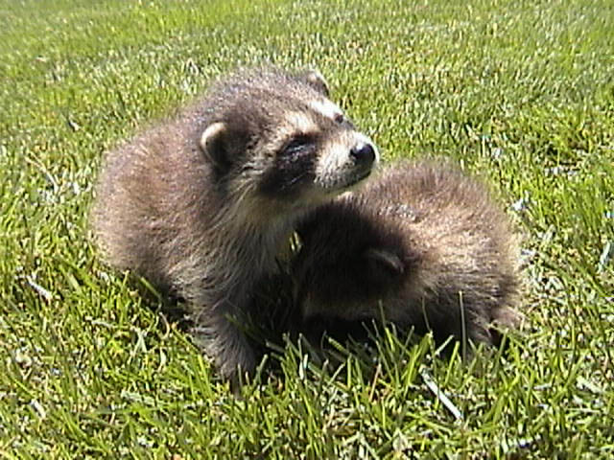

**CARE OF ORPHANED RACCOONS**

For Wildlife Guardians of Ontario

This information is from a conglomerate of sources including IWRC & experiences of several Canadian Wildlife Rehabbers.

**Index**

Infants Page 3

Keep Warm Page 3

Examine Page 3



Dehydrated Page 3

Re-hydrate Page 3

Formula Page 4

Nipples Page 4

Weaning Page 4

Post Weaning Page 4

Wild Diet Page 4

Store bought foods Page 4

Poop & Pee Page 5

Housing Page 5

Roundworm Page 6

Quarantine Page 7

Diseases Page 6

Lung Infections Page 7

Coccidia Page 7

Toxemia Page 7

Release Page 7

Fast Release Page 7

Post Release Page 7

Growth Chart Page 8

Feeding Chart Page 9

INFANT RACCOON

**Keep Warm:** Put the baby/babies in a box or cage with lots of rags and place a portion of the box/cage on a heating pad on **low,** leaving a portion unheated to allow the baby to move from the heat if necessary. Hot water in a jar, wrapped in a towel or a ‘hot water bottle’ can be used but the temperature must be monitored. If eyes are closed they will not climb but if eyes are open a secure lid is recommended so they don’t climb out.

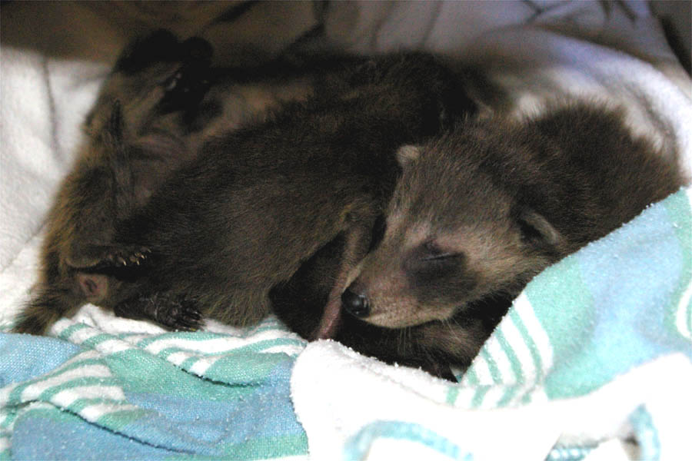

**Find a wildlife rehabilitator** in your area and get the animal to them as soon as possible. Can't locate one yet? Do the following and get the baby to a rehabber as soon as possible.

**Examine** Let’s take a good look at it. Do you have some latex gloves you can wear? Write down what you find. If you cannot differentiate between the raccoons put a non toxic coloured mark on their foreheads or small coloured thread about an ankle. …note also if they are male or female…if you are unsure it is probably a female.

If possible weigh the animal [kitchen scales] and weight will determine food intake and allow you to track the growth of the baby.

Watch for *fleas and lice* [some look like dandruff] and treat as you would a feline kitten. *Be careful with flea powders or sprays which can harm their lungs, put on to your fingers then apply sparingly to baby. Flea shampoos or Selson Blue can also be used. Frontline or Advantage spray or drops for cats may be used on your raccoon. You can try putting a little Garlic Juice in the food almost every day.

*Discharges from body orifices?* *Maggots?* Check ears & under armpits for *ticks*. Does it look healthy or sick? Any of the above call a vet or treat like you would a cat, puppy or other infant wildlife.

If they have any of the above and you don’t know what to do, you get to go to your local vet!

**Dehydrated?** Baby has been without Momma for how long? Don't know? Then presume it is dehydrated. Pinch the skin. If it stays ‘pinched’ it is definitely dehydrated. You need to Re-hydrate.

**Re-hydrate** all orphans for a day at least or more, if the animal needs it. *Home made version: 1-teaspoon salt, 1-Tablespoon sugar and 1 quart warm water OR G*atorade if you have it in the house. If you want to buy something go a pharmacy and ask for Pedialyte a liquid of which you will throw out most of it or powders like Gastrolyte, which you can mix what you need. Administer with eyedropper or preferably a syringe [no needle]. You can get them from 1 to 10 CC sizes.

Wean the baby from the rehydration fluids onto the KMR formula over a day or two, depending on how dehydrated it is. Give ¾ hydrating formula + ¼ formula. Next feeding ½ + ½. Then ¼ + ¾ etc.

**Formula:** Raccoonmilk is high in fat, protein, and calories. KMR used to be the replacement formula of choice until the company changed the formula. Today most of us are using Raccoon Formula from Fox Valley [nklc@aol.com](mailto:nklc@aol.com) (815) 385-6404 [www.foxvalleynutrition.com](http://www.foxvalleynutrition.com)

Mix per instructions of which ever formula you use Administer with bottle or syringe. Raccoons love to suck and take quickly to human baby bottles although if very small and preemie nipple makes it easier. [I find most will take the bottle] At first they may not want it, as it does not taste like Mom. Slip a syringe between their lips and force some in. Very quickly they get the idea and adapt to the new taste. Rub some formula on the nipple and they will probably take it. They are small and will only take a small amount depending on their size, note the chart below which will give you an idea of the approximate amount of intake. When they don't want more, stop. Watch their belly; do not feed so much it gets distended.

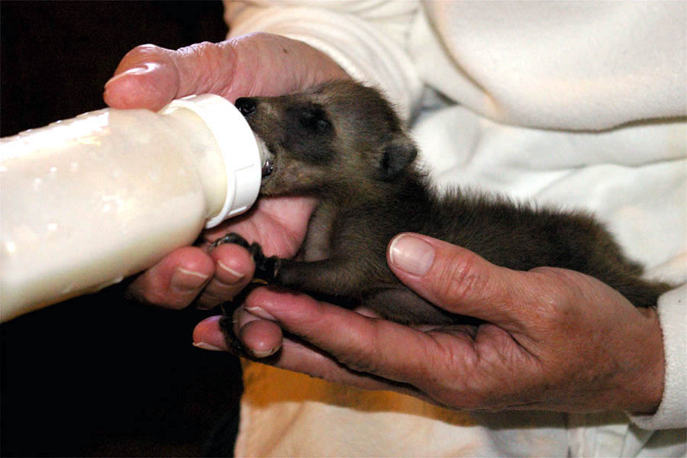

Feeding intervals depend on age and weight and the individual animal. Raccoons under 150 g may need five or six feedings per day. From 150-300g., they will likely require four feedings a day; from 300-600 g., three feedings daily may be sufficient. Amounts fed will vary by individual animal. A comfortable rule of thumb is 50 cc. /kg. Feed with the animal on its stomach, not flipped on its back.

**Age, Feeding Schedule** *For amounts and weights note chart at the end.*

**Nipple Extras**: if the nipple aperture is too large, the animal will take in too much formula and often it will bubble out the nose. This situation has the potential to cause aspiration pneumonia should the animal inhale the formula. A set of similar sized nipples be given graduated aperture sizes. This helps prevent the problem of taking a nipple with a small aperture and making it larger and then not being able to use it on the next small infant. Finding nipples with small holes can be accomplished by purchasing preemie or juice nipples. Nipples should be kept very clean by washing with dish soap and hot water after each use. Old nipples that are frayed should be discarded. The size of the aperture on that nipple is too large for most infant mammals as well.

Many other types of nipples have been use for wildlife rehabilitation; Small mammals are often raised using "pet nurser" nipples. Some people have gotten creative and adapted their things to work. For examples, 3 cc syringe with a pet nurser pressed over the top of the syringe allows for the use of a nipple in a system where positive pressure can be applied and milk can be dripped onto the tongue to tempt them to feed.

*Never reheat the formula in a microwave as essential enzymes are destroyed. Mix small amounts and warms up in hot water in a bowl.

**Weaning**: Introduce blended puppy kibble (a reputable brand, not generic) into the formula by four weeks of age. Offer moist puppy kibble from 6 weeks of age onward. Wean as early as possible. Certainly, there should be no bottle feeding by the age of 9 weeks. You might want to feed them in a tub as they are quite messy and this makes easier clean up for you.



**Post weaning**: Offer dry kibble at all times. Choice between Natural foods and Store bought foods.

**Wild Diet** Two to three times daily, offer moist foods including natural foods such as chicks, rats, mice, crayfish, fish, insects, mollusks, clams, oysters, insects, snails, frogs, worms, and young fish, birds, and mammals, corn, acorns, fruits, berries and fruits. Offer live foods only to pre-fasted animals. Usually the first kill is not efficient (they may bite the tail end of the animal). Do not start with a prey animal capable of mounting a major defense to the attack (i.e., large rat). Instead, start with a crayfish or fish and work up to mice and then rats. Following the first kill, they usually learn to go after the head or neck and quickly kill their prey provided they are hungry.

**Store Bought Foods.**  For those who don’t have access to a raccoon’s normal food, you can substitute human foods. They require fruit vegetables, calcium, and protein. You can use unthawed mixed frozen veggies [be sure they get some broccoli and cauliflower for calcium], no name fruit cocktail with syrup rinsed off. Cottage cheese for calcium, cooked chicken for protein and bones for calcium. A cat/dog one a day vitamin never hurts.

How much? Watch, use common sense, if they are getting too fat, cut them back. As they finish cleaning out the dishes you can add a bit more next meals. By 8 weeks they should be on solids about 3x a day; By 3 months they could go down to 2 X ad day

**Never use any type of cat foot or any canned pet food. Chocolate and salt can kill infants.**

**Poop & Pee:** After feeding stimulate the intestinal and anal area, Momma coon would have done this by licking in a downward motion to their bum. You can do the same with a warm wet rag or cotton ball. If very dehydrated they may not urinate or defecate immediately. They normally will do this on their own after their eyes are open but at first no matter the age you do it until you are sure they can. [Normally the often go 2x a day]. When eyes open put a small container they can climb into with unscented clay kitty litter. [Note ‘Bathroom’ below] stool will turn to soft yellow and should be formed-watch for diarrhea. A couple of drops of Kaopectate can be used for diarrhea. [Gloves, hand washing and careful hygiene are recommended here as raccoon feces carries a roundworm that is very harmful to humans and pets.]

**Housing**

Your little infants need appropriate size caging. Much depends on the number of raccoons you have. They will need room to run and climb. I go through a series of cage sizes ranging from hamster cage; double hamster cage to rabbit cages [3’x2’], or large dog steel dog cages, [covered in ½” chicken wire] while they are indoors. From 3-4 weeks they should have a heating pad under *part* the cage. If they get too warm they can move off it. Hot water in a jar, wrapped in a towel or a ‘hot water bottle’ can be used but the temperature must be monitored.

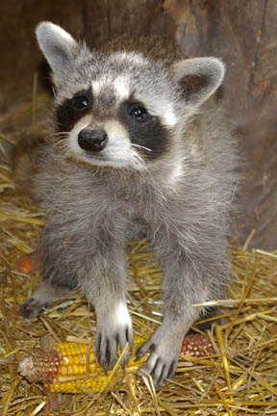

Several cozy rags can be used for a nest, but make sure there are no reveling edges that they can get tangled up in. A nice little box with holes and a lid make a great house. A series of plastic containers with appropriate air holes and doors etc work well and are easily cleaned. As the baby grows they prefer their house to be up high, if that is manageable.

Note that as they get older they can often figure out how to open their cages in was you can’t imagine!

Once their eyes are open put a small container of kitty litter in the cage for them. It is amazing how quickly they will use it.

Once the weather is moderate, and they are approx. five weeks old they can go in ‘the big cage’ outside. This cage is 4’h x 4’w x 6’l and made of ½” wire around a wood frame. I use this size for 3 raccoons.

Kitty litter [note bathroom section below] is placed in two corners. So rehabbers prefer to put straw for the flooring. Note it must be changed very frequently as they will use it for a toilet and fleas and mold can form quickly.

Large plastic container boxes [with lid] have plenty of air holes and a door cut out. These can be used later [with the door hole plugged] to transport them to the wild. Rags are used for bedding and when older you can provide them with leaves, twigs etc. to line their nest. They are also waterproof. Raccoons like to be up in trees so mount the box securely on a shelf near the top of the cage.

Some make permanently mounted wooden boxes or secure the plastic ones to a wooden shelf.

They also love to have a hammock to play, swing and sleep in up high in the cage. It can be made from old blankets or sweatshirts. Don’t forget to branches to play in.

Pine cones and stones make good toys as well as most toys you would give a human toddler. They love to play toys help them develop the dexterity required in the wild. They will even wind a clock.

Water should always be available. Some rehabbers keep food in the cage at all times others prefer to have feeding time and remove to keep the flies and parasites down.

Make sure there is a container of real garden dirt in the cage for them. They will eat dirt for minerals and assorted insects as well as play in it.

Make sure there is shade for them. This can always be achieved by a tarp on top of the cage.

If you can’t let them out of the cage for a romp, make sure the cage is larger. They love a dishpan of was water to play in and learn to catch fish and crayfish in. Put some stones in it to practice with.

IWRA recommends 6’x8’x8’ for 4 raccoons, which frankly I think is way too small to achieve decent exercise.

**Roundworm:**  Raccoon feces caries a very dangerous type or round worm that can be transferred to other animals, pets and humans. It is very strong and cannot be killed by even bleach. Once a cage is used for raccoons it should not be used for other animals. Bleaching the cage after use is till recommended for other parasites and bacteria.

Raccoons **must be dewormed** once a week with Strongid T .25ml per pound of raccoon. We usually wait until their eyes are open to start, however if you are having with digestive problems with your baby diarrhea, gas, vomiting, try the strongid.

**Quarantine**  of incoming animals is recommended for two weeks before introducing them to another group. We have seen lung infections and other serious transmittable diseases wipe out several litters. It doesn’t happen often but it is devastating when it does.

If one of your litter is ‘acting stangely’ quarantine it until you are sure it well. It is not worth risking the lives of the whole litter.

**Diseases**

As you gain experience you will learn to recognize specific signs and symptoms of various diseases. As you learn keep a book that you can refer to later. Until then. Think of these babies much like a kitten. If they eat, poop and play…they are usually doing well. If any of those change, there is a problem. Call a fellow rehabber or get to a vet. If it doesn’t look ‘normal’ it isn’t. If they start staggering, walking in circles or sleeping too much. Call a fellow rehabber or get to a vet.

**Lung Infections** can come from aspirated formula, which their tiny lungs are unable to cough out. It becomes infected and eats away at the lung until it is perforates in the chest cavity and they die. This is probably the leading cause of infant death after they are orphaned.

Some lung infections are from exposure and malnutrition. If suspected get the animal on antibiotics immediately. To the Vet!

**Coccidian** a devastating disease as it is very contagious and can wipe out your whole litter. Symptoms will be apparent about one week after exposures so in most cases this will be very shortly after you receive the babies. Symptoms include: Blood in stool [the poop looks very dark/black not red]. Diarrhea, sever cough’ runny eyes [almost like a white glue and is difficult to dissolve]; near the end convulsions. Beware that fatality rate is high. Most rehabbers have the animal put down when convulsions start.

Treatment-Get to a vet! Quarantine your animals, blankets, bottles etc. For one rehabber Amoxicillin was given twice a day then was followed by a Sulpha Drug S125, was proscribed one tablet twice a day crushed and given in their formula. [Unfortunately the whole litter died] But give this information to your vet so they know what has happened preciously and contact me to change this if it occurs to you and various treatments were successful. Email- [lbeechey@amtelecom.net](mailto:lbeechey@amtelecom.net)

**Toxemia** all though rare does occur in wildlife babies. Symptoms include sudden signs of distress: crying; dragging their behind; assuming a fetal position; lethargy and lack of defecation. Can be fatal within 10 hours and only if diagnosed immediately, extensive, heroic measures by a veterinarian might be successful.

**Canine Distemper & rabies** signs are very similar and include paralysis, paresis, head-tilt, and facial twitches. This is a virus that is spread though the qerosols of nasal discharges. Common signs include neurological (convulsions), respiratory signs (pneumonia), and diarrhea. This disease is so often fatal in raccoons that once diagnosed, they are usually euthanized.

**Release**

Raccoons are released at about 16 weeks of age, depending on the individual and the way in which they are released. Those that are slow released [open the cage and they come and go], can be release earlier (l0-12 weeks)'

MNR regulations state they must be released withing 15km from where they were located. Make sure there is water, berries, food etc in the bush.

**Fast Release** Raccoons that are released without back-up food should be really self sufficient and good hunters and foragers. They are typically 16+ weeks of age and have had some practice in your yard.

They should be released in their proper habitat, neat a source of water, late in the day or in the evening. Care should be taken not to place them in areas where prey species are of special concern, the numbers of raccoons released in a given area should be tightly controlled so that their impact on the area is minimized. They should have had no

interaction with dogs!

**Post-release** feeding can be provided for several weeks or until not longer utilized by the raccoon. Feeding stations should not be permanent! Good rule of thumb is to take food out for them every day the first week. Every second day the second week. Every third day the third week. Unlike other animals raccoons will hang around for the food and you must wean them off. Do not bring them their favourite treats. They must learn to forage for their own food.

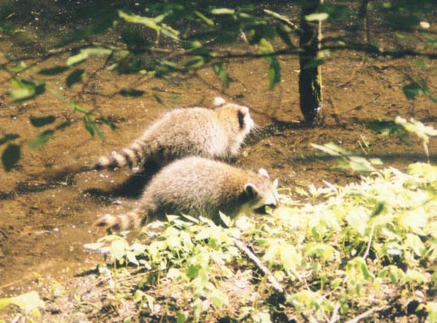

It is hard to leave them, they will often follow you or your scent so be careful leaving.

After a few days or a week you will find they will have much less to do with you. This is a good thing, really.**Growth Chart**

|  |  |  |  |  |
| --- | --- | --- | --- | --- |
| Birth | 62g & 100mm [4”] | Large head ears sealed, eyes closed. | Heating pad partially under cage-watch for dry skin |  |
| 3-4days | 60-70 g up to 140g | lose umbilical cord |  |  |
| 1 week | 100g | Fuzzy fur, faint mask spider crawling |  |  |
| 14 days | 200g | Mask defined, **tail rings,**  Ears flat to head  Holding with hands |  |  |
| 3-4 weeks | Approx. 350-400g | Eyes open by 4th week | Heating pad can often be removed at this time if there are siblings |  |
| 4-5 weeks | Approx. 500g | Ears unfold  Vision still cloudy  Eyes can cross  Wobbly walking  Teeth are coming in | Put litter in cage | Can try soaked kibble mixed with formula |
| 6-7 weeks | Approx.600-700g | Getting mobile  Start climbing in cage | Use water bottle | Start sampling alternate foods. |
| 7 weeks | 700-800g | Run, walk, climb  React to motion objects and light |  |  |
| 8 weeks + | Approx. 850g + |  |  | Should be in large outdoor cage |
|  | These are the fun | weeks when they grow | Like weeds and | Play. Enjoy! |
| 16 weeks |  |  |  | Mom’s milk dried up |
| Anytime after | 16 weeks the | Raccoons can be released |  |  |

**IWRA FEEDING CHART**

A comfortable rule of thumb is 50 cc./kg The following chart is to be used as a guideline.

Remember every animal is different and will eat varying amounts.

How to use this chart: Weigh the animal periodically. Refer to the table on the right and based on the feeding intervals used, feed the corresponding amount shown.

**AMOUNT TO FEED AT VARIOUS**

**DAIILYCALLORIC FEEDINIG INTERVALS IN C C**

Body Weight Intake Reqmt Convert cc to oz divide by 28.35

**Oz grams KCALS/Day 3X/day 4X/Day 5X/day**

1.76 50.00 14.80

2.65 75.00 20.06 ___

3.53 100.00 24.90 5.72

4.41 125.00 29.43 6.77

5.29 150.00 33.74 7.76

6.17 175.00 37.88 8.71

7.05 200.00 41,87 9.63

8.82 250.00 49.50 14.22 11.38

10.58 300.00 56.75 16.31 13.05

12.34 350.00 63,71 18.31 14.65

14.11 400.00 83.24 20.23 16.19

21.16 600.00 95.44 23.92 19.14

24.69 700.00 107.14 41.05 27.43 21.94

28.22 800.00 118.43 45.37 30.79 24.63

31.74 900.00 129.36 49.56 34.03 27.22

35.27 1000.00 140.00 53.64 37.17 29.74

38.80 1000.00 150.37 57.61 40.23 32.18

42.32 1200.00 160.51 61.50 43.21 34.57

45.85 1300,00 170.45 65.30 46.12 39.18

49.38 1400.00 180.19 69.04 48.98 41.42

52.91 1500.00 189.76 72.70 51.78 43.62

